吉林大学

DB2 实验报告

班级：计科 4 班姓名：马兆星 学号：21230415

姓名 | 马兆星 | 学号 | 21230415
实验项目 | 1. DB2 customization
实验性质 | □演示性实验 □验证性实验  - 操作性实验 □综合性实验
实验地点 | 计楼 A210 | 机器编号
指导教师 | 康辉 | 实验时间 | 2025 年 9 月 21 日 8 时 00 分
一、实验综述
- 实验目的及要求
This exercise will let you explore the CLP and DB2 GUIs, making you familiar with them using the DB2 default instance - DB2 - and the SAMPLE database. At the end of the lab, students should be able to:
  - Use the CLP
  - Use the different GUIs
  - Know the possibilities of the CLP and the GUIs
2. 实验设备、软件
PC, windows XP Professional, DB2 9 Express-c
二、实验过程（实验步骤、记录、数据、分析）
Section 1 - Exploring the CLP usage
- If using a Windows system, and you are not already logged on, log on now using the DB2 Administrator name. Use your Windows username and Windows password.

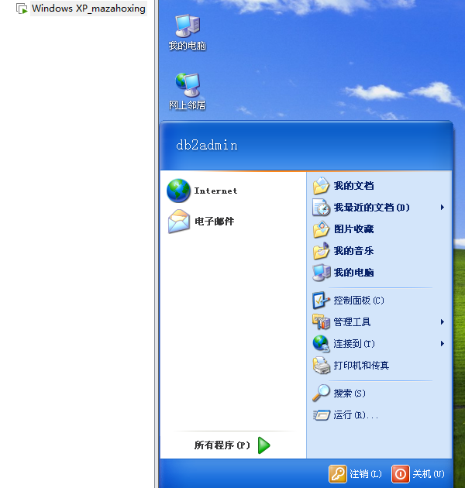

2. First, try to get general information about commands that can be used in the CLP.
Show your work below by printing screen.

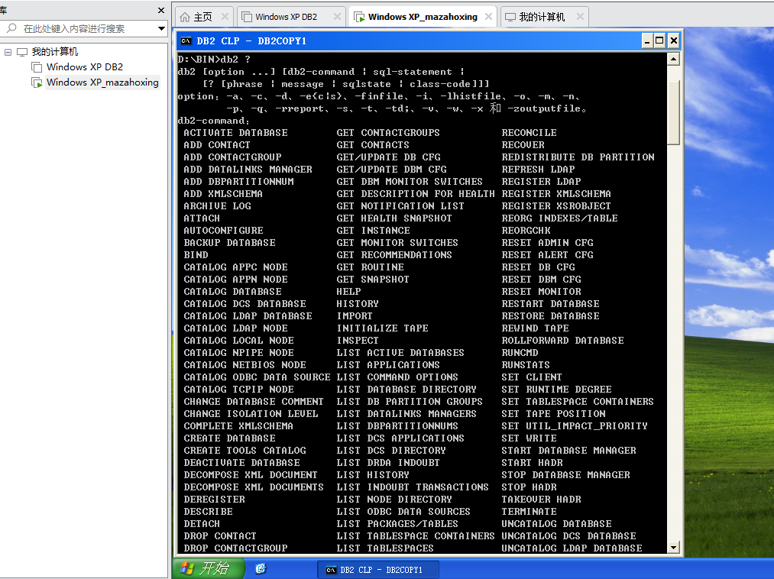

- Now examine what can be done with the get command.
Show your work below by printing screen.
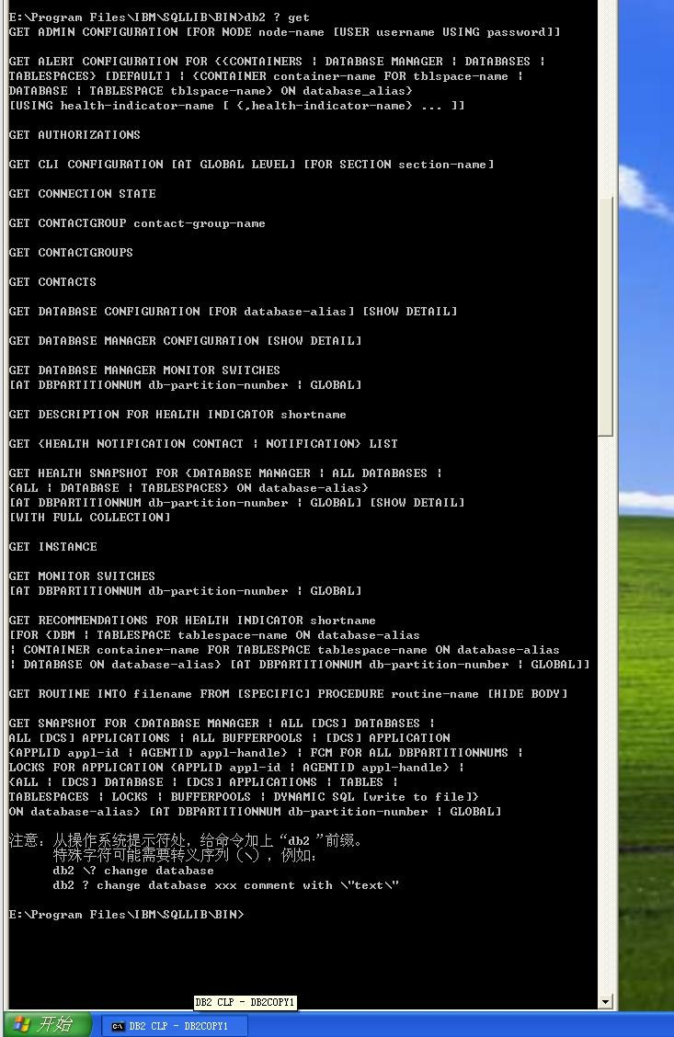

- Next let’s assume you receive an SQLSTATE=08003. How you can determine what this sqlstate means? Execute the correct command and explain the meaning.
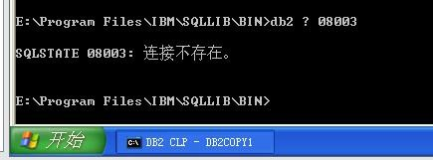
- Next let’s examine the options set for your CLP session. Issue the correct command and determine which options are set to on.
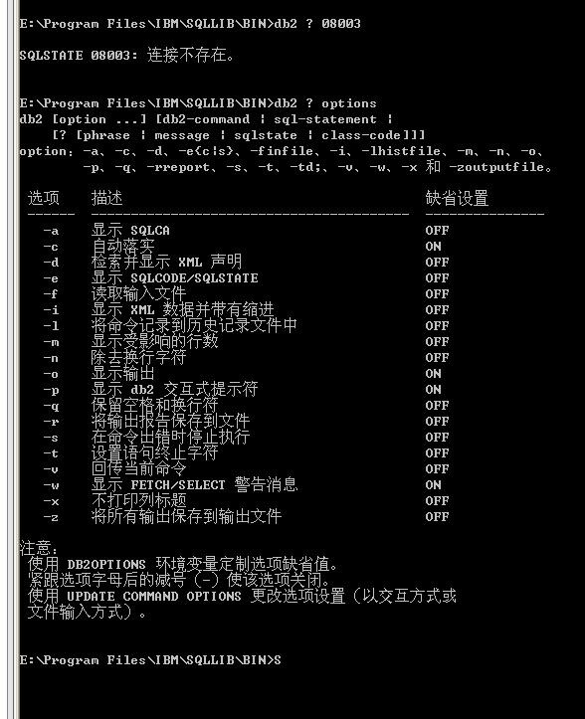
- Next let’s create a script with the name myscript, which connects to the sample database, selects the columns empno and lastname from the table employee and lists the database manager configuration.
Show your work below by printing screen.

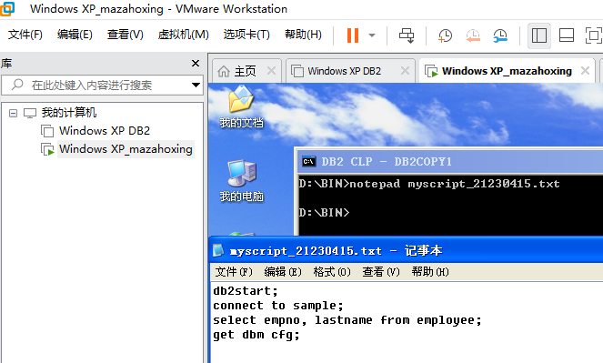

7. Now execute the created script using your CLP session and echo the current command.
Show your work below by printing screen.

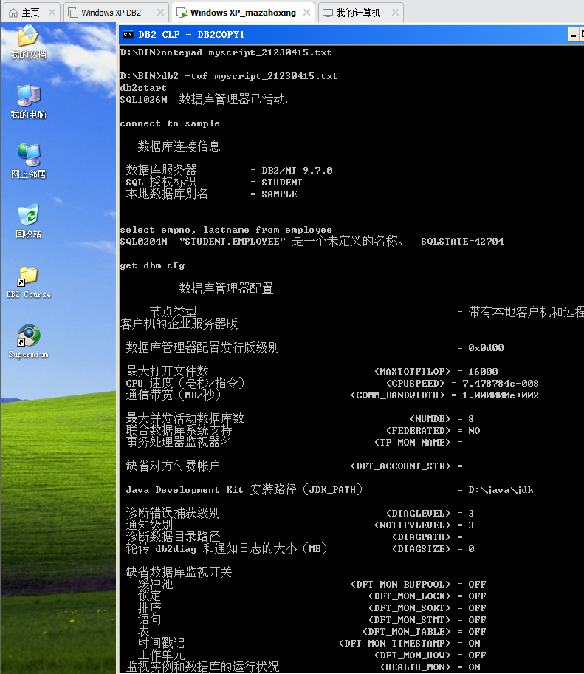

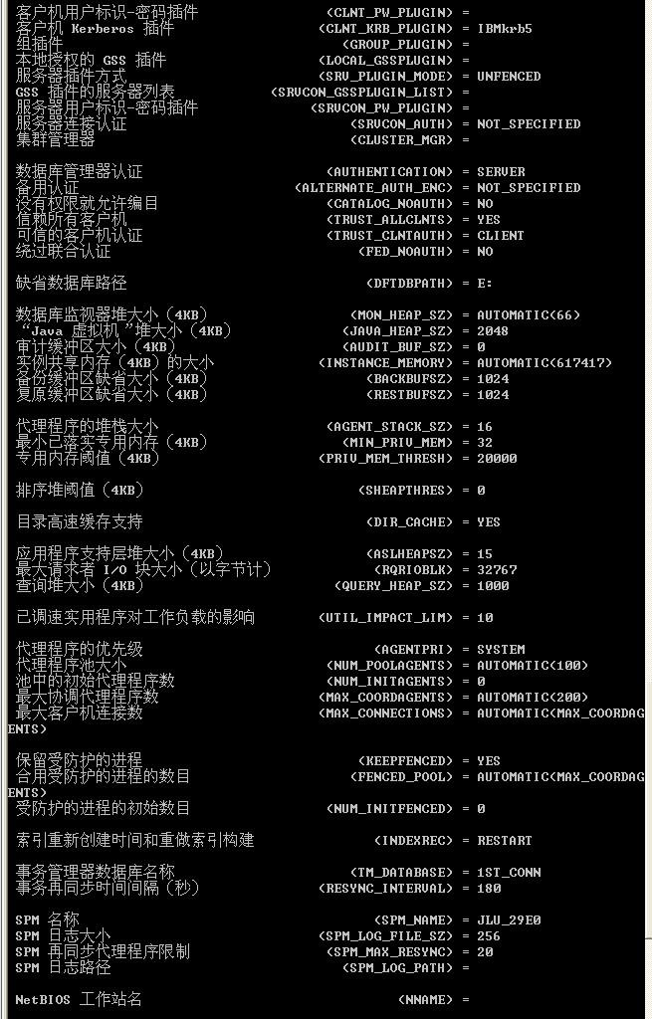

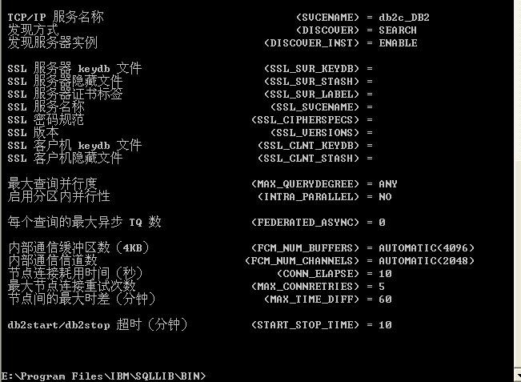

- As there is a lot of information returned from the select statement and the database manager configuration, it might be helpful to store the information in a file called myout to be able to examine it step by step. Execute the script again and save the output in a file named myout.

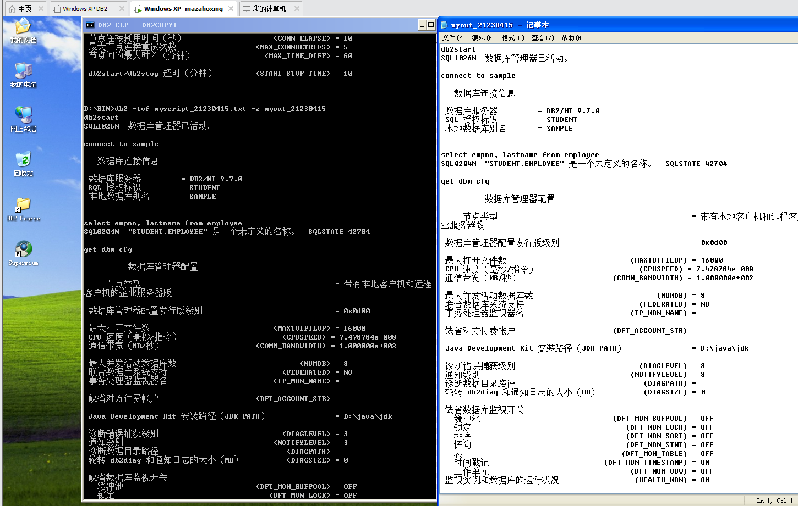
Show your work below by printing screen.

